Worksheet: The many benefits of breakfast (from WebMD)
Pre-reading
Discussion questions
- Why people say breakfast is important meal of the day?
Because is give an energy for a whole day.
- How often do you skip breakfast or have it on the go?
Sometime.
- You work up late, it time to go to school, and you still need to finish your homework. Should you skip breakfast?
No, I will eat it in the same time with doing a homework.
- What kinds of food are considered healthy breakfast?
The food that contains all five categories of nutrient.
- Do you pay much attention to what you eat?
I pay full attention.
- Do you think you have a healthy life style?
Yes, because I eat the breakfast that has Carbohydrate.

Post-reading
1. Please write down 3 reasons to eat breakfast.
1. To lose weight
2. To receive the energy for the whole day.
3. Lower choresterol.

2. Research about triglyceride and cholesterol
Compounds | 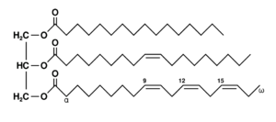  Chemical Structures | What is it? | Role
Triglyceride |  | A type of fat that can digest and can be produce in the body. | A source of energy. Stored a fat.
Cholesterol | 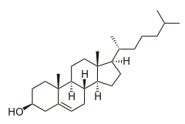 | A fat substance in the body. The body can makes it and it is in the food too. | Make hormones, vitamin D, and digest foods.

3. What is the difference between triglycerides and cholesterol?
Triglycerides provides an energy, but cholesterol not. Cholesterol uses to make a hormones. Vitamin D and digest food.

4. Explain why having high level of cholesterol and triglycerides in the blood system will lead to a high risk of heart disease.
If there is a triglycerides or cholesterol stuck in the blood clot, it is hard for the blood to pass thought. Lower amount of oxygen from the blood, the heart become weak. That lead to the heart disease.

5. Design your experiment how to study eating breakfast can help you do better in school. Example would be to monitor a different type of food, the energy level during school period etc.
I will set 3 group of a student in the same grade and let them eat a different kind of breakfast. Group A eat cereal. Group B eat egg. And group C eat an oatmeal. For 1 month. After 1 month I will test them with the same test, and look how they do. So, I can know which kind of breakfast is the best.

