image | name | price
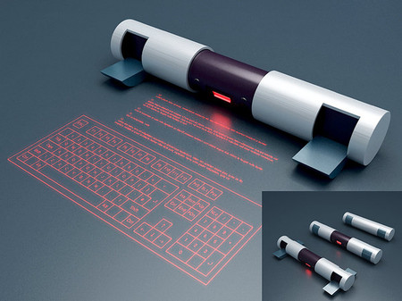 | future-Cube Laser Virtual Keyboard | 15693 bath
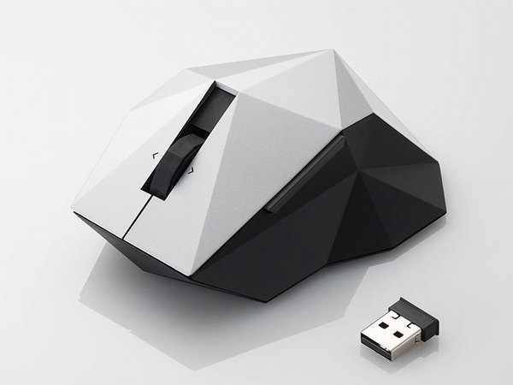 | Orime Mouse by Elecom x Nendo | 1500 bath
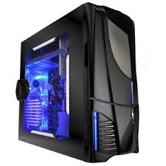 | Ark Technology PA08 Ark Technology PA-08 Black ATX Mid Tower | 20139 bath
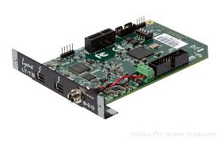 | Lynx Studio Technology LT-TB: L-Slot Thunderbolt interface card | 2599 bath
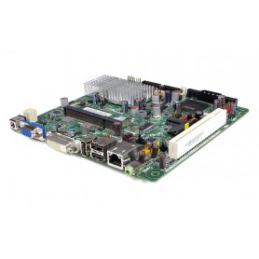 | Intel D945GSEJT Johnstown Fanless Mini-ITX Motherboard | 3450 bath
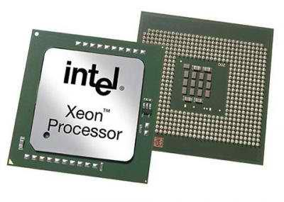 | Intel Xeon processor | 13042 bath
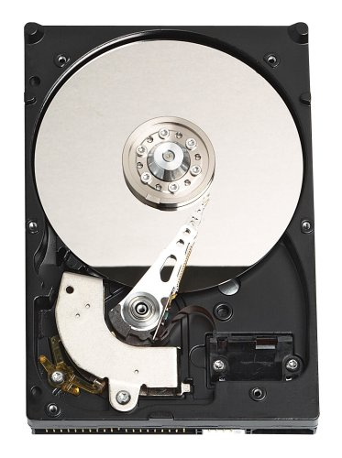 | Hard Disk Drives Technology | 6520 bath
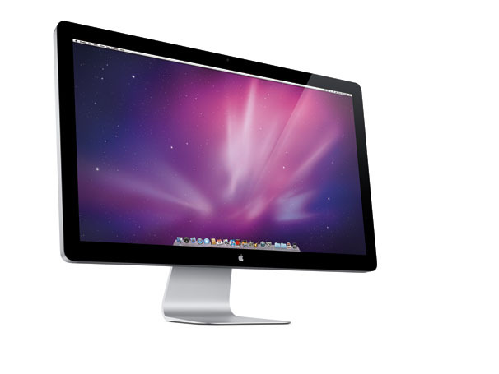 | Apple 27-inch LED Cinema Display | 5800 bath
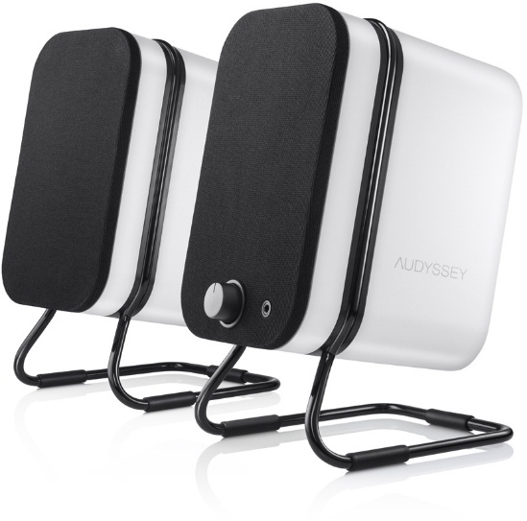 | Audyssey  Wireless Speakers | 6550 bath
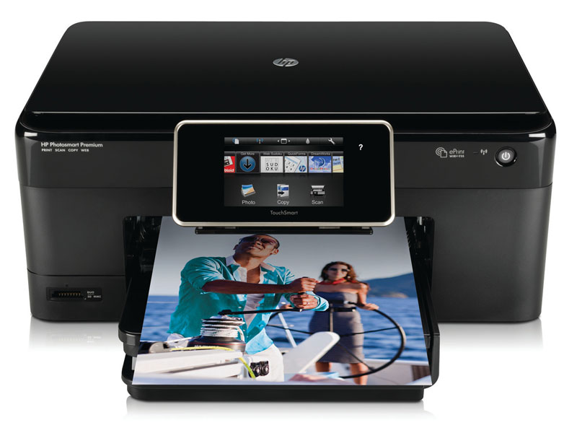 | HP Photosmart Premium Printer | 8560 bath

