Flashlight Circuit board report

In this activity, I build a simple circuit by using resistors, battery, LED, and switch. This allow a current to flow to the circuit and light up the LED. This activity includes a switch which there isn’t in the previous time. It was interesting and I had tried many times to make the circuit succeed.

Photos
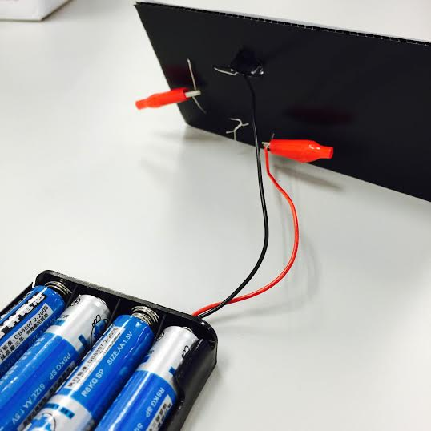
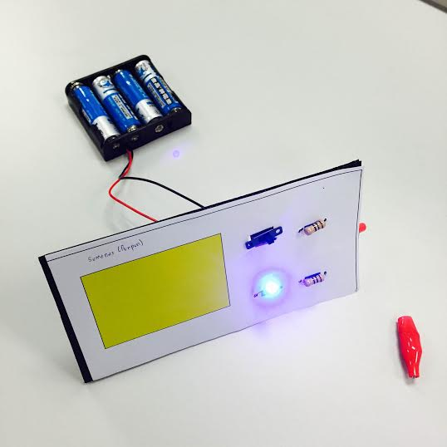

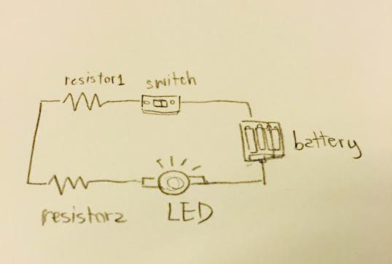
Schematic

Procedures
- The first step is to make a hole on the board.
- Put 2 resistors, a switch, and a light bulb into each hole.
- Bonds together 2 resistors, one resistor with a light bulb, and another with the switch. Use clips to clip them together.
- Connect the battery to the circuit by clip the black wire to the light bulb, and the red wire to the switch.
- Turn on the switch.

Physics
This circuit is a series circuit which the current flow through the wire to the LED by using the equation of: R (series) = R1 + R2 + R3 +…+ Rn.
According to the previous class, I had measured the voltage from point 1 to 4 on the schematic using 3 resistant (This time use only two). For the point 1 to 2 which is the resistor1, the voltage is 1.52 v. From point 2 to 3 or the resistor2 is also 1.52 v. In addition, the voltage from point 3 to 4 which is the LED is 3 v. Since this is a series circuit, the final sum of all the voltage is 1.52+ 1.52 + 3= 6.04.

Summary
This activity required a student to guess how to complete the circuit. I needed to try build it in many different ways. For the example, use the red wire instead of the black wire to connect with the LED, otherwise the LED will not light up. The current passes through a wire from the battery to the switch, resistor1, resistor2, and the LED in an order. The LED finally light up in this step.

