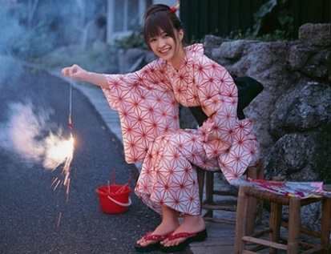
Name: Shinosaki Rika
Age: 22
Hometown: Aomori, Tohoku, Japan
Profession: Novelist

Country overview: Japan is a nation-state because of its self-identities and political idea. It has a territory of 6,852 islands which is an archipelago along the Pacific Ocean. The four largest island are Honshu, Hokkaido, Kyushu and Shikoku. There are 8 regions and 47 prefectures. It has a population of 126 million which is the world 10th place of the largest number of population and one of the most densely populated countries. Japan has a constitutional monarchy with the limited power of the emperor. The power is primarily held by a prime minister and elected members. The sovereignty is conferred to the Japanese citizens.

My rights:
- Periodic, free, and fair elections: A right to change the government peacefully is exist. The country is a parliamentary democracy governed by the political party. In June 2003, there were 43 arrests during political corruption and violation of the Political Funds Control Law since citizens having a right in practice, periodic, free, and fair elections.
- Freedom of speech and press: Allowing to stop news that they consider unfavorable to them. Article 21 of the Japanese Constitution guarantees a freedom of expression and prohibits formal censorship.
- Freedom of peaceful assembly and association: government needs to respect every rights. The citizens have their individual right or ability to come together and express, promote, and tell their ideas in the public.
- Freedom of religion: No religion can has any privileges from the State. No person can be forced to take a part in any religious practice. “Shinto” is the Japan’s main religion. However, Japanese can choose to be in any religion they wanted. For this reason, there are a diversity in religion in Japan. In 2008, there were 51.82% of Shinto, 34.9% of Buddhism, and other minor religions such as Christianity, Baha’i Faith, Islam, and Judaism.
- Freedom of movement: Citizens have the right to travel freely both in the country and abroad. They also can change their place of residence, and even to emigrate. A legal status in the country is provided for a refugee during the refugee recognition process.

My duties:
-The people need to have a responsibility to taxation.
-Protecting the nation and being loyal to the government.
-Joining the Self-Defense Forces or the police.
-Becoming gainfully employed with a sufficient income.
-Behaving well, no violation.

