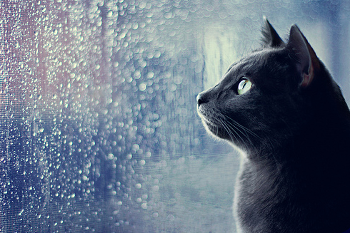

Concept: Sadness
Message: Alone in the rain
Angle of the Message: the sadness to stay alone with cold rain.
Audience: everyone that feels lonely.
Emotional Connectors: feel sad and lonely to watch the rain alone.
Creative Composition: the camera focus on the cat and the background is only a window with a rain. It makes a lonely feeling.
Dynamic Artistry: grey and purple color tone in the picture can tell how depress.
Story Telling Quality: the picture tells about the experience to be alone.

Concept: happiness
Message: warm family
Angle of the Message: happiness of the children that play in the orange, warm sky.
Audience: people that want to be happy with a little thing.
Emotional Connectors: feel happy to play all day like a children.
Creative Composition: camera focus in the front of the children (the direction that they run to) while they laughing and playing.
Dynamic Artistry: black and orange color tone represent fun and party theme and also mean warmth.
Story Telling Quality: the picture tells about the children while they are having fun, make the audience feel relax. And for some people, they can also notice about a happiness that can come from such a small thing. So, they can feel good to stay with their family.

