Focusing your Research Topic

Begin by selecting several topics that interest you. Do a small internet search to learn a bit more and see if this topic interests you. You also might want to see if there is enough information available.
Once you have an idea in mind, you need to make sure it is not too broad or not too narrow. If your topic can be summed up in a word or two, like smoking, school violence, education, overweight kids, capital punishment, World War II, or rap music, your topic is too broad.

One reliable method to use to narrow a topic is to narrow it by different contexts. You might recognize this as Who, What, Where, When and sometimes How and Why.
As an example, suppose a student has picked a very broad topic of eating disorders. Eating disorders is a very broad topic, so it will be necessary to narrow the focus.
The following organizer can be used to help you narrow your focus:

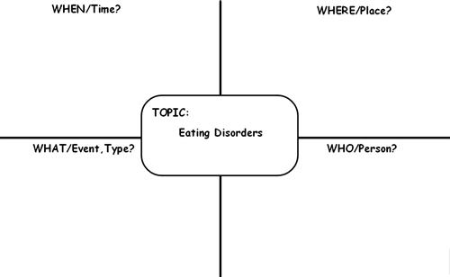
Topic: How Japanese culture affects Thai teenager?
When: in nowadays
Where: in Thailand
What/event, type? : affect in food, music, and fashion.
Who: teenager

WHEN - This would be a time frame. It could be a current or historical view. You might also consider comparing different time periods, or show the evolution of something (how it has changed over time).
WHERE - This would be locations or places. It could be regions, states, countries, or it could compare different locations. It could also be places like school, the workplace, college.
WHAT - This would be events or types of something, depending on the topic.
WHO - This would be the person, group, or a population defined by gender, race, ethnicity, educational level, nationality, occupation, species, or age.
* You can use how and why, but they don't always work as well for narrowing down a topic. These are better saved for when you make your question.
Other aspects to consider (depending on your topic) are viewpoint and causes and effects.
Viewpoint would look at the ethical, medical, social, economic, legal, political, religious, biological, psychological, or historical aspects of a topic. For example, What are the psychological factors that lead to ethnic violence in modern-day Myanmar?
Causes and Effects would examine the factors that influenced or brought about the topic, or what influence or effect the topic has had on a group of people, a place, or other topics related to it. An example of this would be How did blues and rock and roll artists influence hip-hop and rap artists?
Below is a sample chart with information to help narrow the topic of eating disorders:
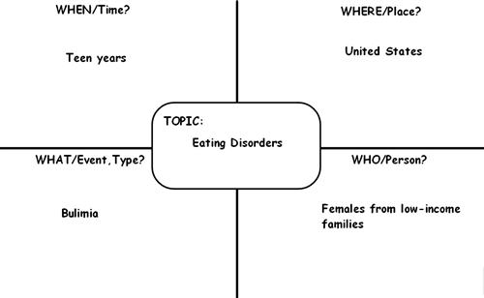
After completing the chart, this topic could be narrowed to - The prevalence of bulimia in low-income teenage girls in the United States.
Once you have a topic and it has been approved by your teacher, you should research more specifically about this topic and make sure there is enough information, that you can understand the information, and that you will not become bored with this topic. Then, you are ready to create your research questions.

Adapted from Butler Area Schools CSD ‘Making your Research Topic ‘Just Right’” http://www.basdk12.org/Domain/4

