Research
- a. Bacteria
b. is a Zoonotic Disease that can cause in both animal and human by the Borrclia burgdorferi [tick]
2. It can’t transmitted between people, but if the person has tick it can transmit.
3. It can attack every part of the body.
4. 1- 2 days to 1 month or longer than that.
5. has a macule or papule, has a fever, stomachache.
6. Many weeks.
7. Bacteria can get into heart and brain if not get a treatment.
8. Discovered by SmithKline Beecham in 1998, can’t be taken after infected.
9. Get vaccine. Don’t go into the forest, if need, wear the shirt that cover all the arm, wear a rubber at the wrist. Completely no space. And don’t forget to put on a mosquito-repellent.
10. Go for a doctor.

LYME DISEASE
A Zoonotic Disease that can cause in both animal and human by the Borrclia burgdorferi [tick] Found in America and Europe. Have vaccine but can’t take after infection.
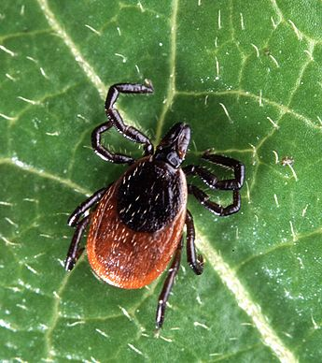

OFFENSES
Attacks
Transmitted to the human by the tick, and use same object with the person who has tick.
Outcome
has a macule or papule, has a fever, stomachache.
Incubation
1- 2 days to 1 month or longer than that.
Duration
Many weeks
DEFENSES
Vaccine
Discovered by SmithKline Beecham in 1998, can’t be taken after infected.
Behavioral
Get vaccine. Don’t go into the forest, if need, wear the shirt that cover all the arm, wear a rubber at the wrist. Completely no space. And don’t forget to put on a mosquito-repellent.
Traetment
Go for doctor.

