TOPIC SELECTION

- Local Community  Choosing this option, you will research an issue that faces a very specific part of the world. It should be something like a city, a village or a community of people.  - Region within a Country  This option includes a slightly larger area. It could be a state or province within a country, a geographic region like a mountain range or coastal plain, or it could be a cultural region within a country.  - Country  This option will allow you to examine an issue facing an entire country, like Thailand or Myanmar.  - Region of the World  This option will allow you to focus on a group of countries, a geographic region, a continent, or a cultural group that goes beyond one country’s borders. An example might be diplomatic issues between the many countries in the ASEAN community. | 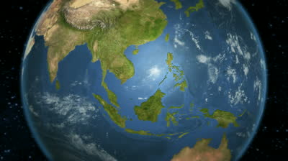  - Comparative  This is the option that allows for the largest scope. If you select this option you will examine an issue that faces the entire world or a large part of human history. Choosing this option will mean that your research will compare two very different peoples, regions, countries, cultures, time periods, or some other category decided by you and approved by your teacher. You will compare them to see how the two examples you have chosen are similarly and/or differently affected by the issue you have chosen.

BRAINSTORM
GMO
-Historical period
- Industrial revolution
- capitalism
-affect
- human
- disease
- animal
-plant, environment
-who
- every country
-for
- make plant grows faster
- more product
What is the scope of your research? (Choose one)
Local Community Country Region Country World Region Comparative
1. Use the space below to explain the region(s), country(s), people(s), etc. that you have chosen to base your research on and what issue therein you will be asking your research questions about.
About GMO, no specific religion, country, or people.
___________________________________________
2. Now, use this next space to explain which historical period you will be connecting your topic and research questions to.
GMO is connect to the industrial revolution and capitalism idea. When the people want more money, they produce more product, and to produce ore product, they need GMO.
Now, you will create questions that will guide your research. First, write 1-3 big questions you have about your chosen topic. Then write 3-5 sub-questions to help you answer your big questions.
YOUR QUESTIONS MUST FOLLOW THE GUIDELINES FROM THE PROJECT GUIDE!
BIG questions:

How do GMO affect our health and environment?

SUB-questions:
- How GMO affect?
- Why they need GMO?
- How can it makes disease?
- How it connect to the industrial revolution?

Teacher Approval:
__________________________________________

