Background
Producing more rice is not enough and that quality is essential. After the food crisis in 2007, Canada’s Department of Foreign Affairs, Trade and Development (DFATD), AfricaRice, and McGill University created a project to develop new rice-based products, innovative uses of husks and straw, improve the policy environment, and build the capacity of rice stakeholders to improve African farmer’s income. The project has promoted the development of equipment for parboiling. Their new products from rice include cereal grain for slow-digesting Type II diabetes consumers. For low-value broken rice, they transformed it into noodles, biscuits, and porridge for children. "Tasty and innovative uses of rice can catalyze rural enterprises and raise income, especially for women farmers and processors in our region," said Ms. Lynda Hagan, scientist at the Food Research Institute (FRI) in Ghana (IRRI, n.d.).
In Nasarawa State, there was a fact that “neither the farmers nor the processors have adequate knowledge, equipment and technique to process the rice after harvest” (Attah, 2014).
In Thai, Permanent secretary Chutima Boonyapraphasara suggested that "Thai rice can be developed as a value-added 'super food' in the form of various products. The commercial rice institute would contribute to adding value to Thai rice so that farmers would receive more income." It could be transformed into various kinds of food for babies, children, senior persons, and those watching their weight. Furthermore, rice could also be transformed as cosmetics and other products (Pratruangkrai, 2016).
Dr. N. Shoba Rani stated about rice quality breeding that it should be improved in terms of color, texture, and aroma by using biotechnology. Dr. K. Alagusundaram suggested on developing dryers and bulk storage of grains (Alagusundaram, n.d.).
Director of the National Innovation Agency Pun-Arj Chairatana said Thai rice needs to be improve for its higher cost. This can created by creative, scientific, and technological marketing for rice products, especially health food. Thai rice can be made into noodles, crackers, flour, health drinks, cooking oil, and other goods. Gaba rice, which has many health benefits, is considered an innovation, as well (The Government Public Relations Department, 2016).
2015, May 20, Thai Prime Minister, Prayut Chan-o-cha stated about “Thailand’s Strategy on Rice Trade Policy” that Thai rice needs to be improve in several ways. On the second part of his speech: Trend, demand, and supply of Thai rice, he told that modern behavior, taste, healthiness, and organic, environmental friendly products is considered as new types of product that consumers are willing to pay extra. This includes higher quality and nutrition. Another factor world’s and rice importing countries’ economic condition. Global economy in nowadays is still fragile needs to be recover. This affected trade and prices of agricultural products. On the other hand, quantity and prices of other carbohydrate products such as wheat can substitute rice and met market demand, especially when the prices of rice is high. He gave government’s 7 strategies on rice as follows:
1) Sustainable and stable rice development plan
2) Creation of fairness in rice trade system
3) Promotion and implementation of rice production and trade at a standard level
4) Capacity enhancement of rice trade system
5) Promote rice consumption value
6) Creation of innovation
7) Capacity enhancement of logistics management (Royal Thai Government, 2015).

Rice Product
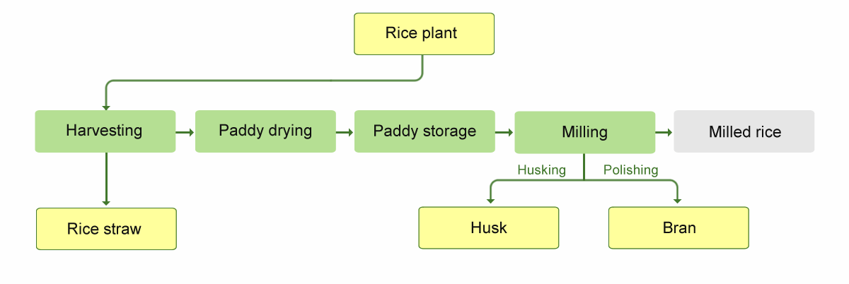
- Rice Straw
Rice straw is produced when harvesting paddy. Rice straw is separated from the grains after the plants are threshed.
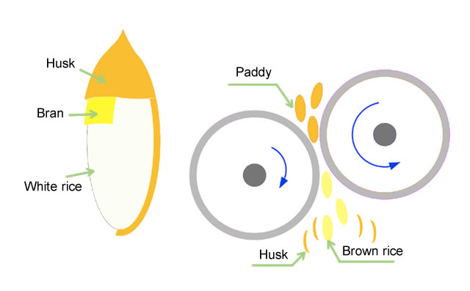
- Rice Bran
Rice bran is produced from the outer layer of the brown rice grain. It is used in cereals, because of its high nutritive value, such as vitamin B6, iron, phosphorus, magnesium, potassium, thiamin, and fiber.
In modern rice mills, several different kinds of bran are produced: coarse bran, fine bran and polish. Rice bran contains 10−23% bran oil. Rice bran can be used as ingredient for animal food. (Rice knowledge Bank, n.d.)
- Rice Bran Oil
It is a high quality, delicate tasting cooking oil that made from the outer layer on the brown rice kernel. It helps in lowering blood cholesterol levels. It can also be used as waxes for cosmetic products. Rice bran and germ oil is also used as a nutritional supplement. Rice bran forms 5–8% of grain weight, and is also used for flours, concentrates, and dietary fiber, as well as for other non-human-food purposes. The main producers are rice bran oil are India, Japan, China and Taiwan.
- Rice Husks (Hulls)
The outer layer of husk which contains many uses of fuel. It can be used as a packing material to pad fragile cargo during shipping.
- Ash from Husks (Hulls)
Ash from hulls can be used to clean teeth and turned into cellulose product. For the example, a sweetener or syrup which produced through a hydrolysis process.
- Rice Flour
It is a gluten free product produced from either white or brown rice ground. Used to produce rice pasta, crisps, cereals and snacks.
6.1.) Rice noodles: Flat rice noodles and extruded round noodles are made from wet-milled rice flour.
6.2.) Egg-roll wrappers and edible rice paper: These are made from wet-milled high-amylose rice batter in East and South East Asia. Edible rice paper is translucent and is used as edible candy wrappers.
6.3.) Rice-flour cakes and dumplings: Across Asia, a wide range of sweet and savoury rice-flour-based cakes and dumplings are generally available for purchase as snack-foods from traditional markets, supermarkets, and road-side stalls. Glutinous rice flour is commonly used to make many of these products, including Japanese mochi and Indonesian layered rice cakes, which require a stickier texture.
- Rice Starch
It is produced from the endosperm of the grain, used as a thickener in sauces and desserts. Also used in the manufacture of Rice Syrup.
- Brewers Rice
An ingredient used in brewing, such as processing in beer and other ferment products. The mash left at the bottom of the container is often prized. It is popular in Philippines and Myanmar. Sake is widely consumed in Japan, as is wang-tsiu in China. These rice-based wine-like beverages are served warm and featured at ceremonial feasts.
- Other
9.1.) Puffed rice: Puffed rice is made by heating rice grains under high pressure in the presence of steam. ‘Rice Krispies’ are one type of popular breakfast cereal made from puffed rice, and puffed rice cakes are a common snack food.
9.2.) Rice crackers: Many kinds of rice crackers are produced across Asia including Japan and Indonesia.
9.3.) Fermented rice food products: These include Japanese miso, Latin American ‘Sierra rice’, and angkak’s ‘yeast rice’. Fermented rice is also eaten in many parts of Asia as a snack or a treat, including in China, India, Cambodia, Indonesia, Malaysia, the Philippines, Singapore, Thailand and Brunei.
9.4.) Canned rice products and quick-cooking packaged rice: Sweet and savoury canned rice products are found in many countries. Various types of quick,cooking or ‘instant’ rice meals or side-dishes, prepared and packaged in different ways, are also available internationally. Instant rice differs from parboiled rice in that it is milled, fully cooked and then dried. There is a significant degradation in taste and texture (Ricepedia, n.d.).
Thai Innovation
From 2011 National Innovation Awards, the prizes were given to ground-breaking rice innovations: Rice-bran oil shortening developed by Thai Edible Oil to meet the need of commercial bakers, a fat-free salad dressing made from rice, and a rice energy drink. There was also an egg coating made from rice starch, developed by Kasetsart University. It prevents oxygen from penetrating the shell, thus keeping eggs fresh at room temperature for up to 28 days. In the past, the award also went to rice innovations such as talc-free baby powder made from rice starch and a ready-to-bake rice flour cake.
The rice-bran oil shortening can be used in baking with only a slight difference in taste and texture from conventional shortening. It has the best soft, stable texture. Rice-bran oil shortening is a good substitute for vegetarians or those with health concerns (Fernquest, 2011).

References

Alagusundaram, K. (n.d.). RICE QUALITY AND VALUE ADDITION. Retrieved from
http://www.rkmp.co.in/content/rice-quality-and-value-addition
Attah, A. (2014, March 6). Adding value to rice through processing in Nasarawa State.
Retrieved from
http://www.dailytrust.com.ng/daily/index.php/agriculture/18334-
adding-value-to-rice-through-processing-in-nasarawa-state
Fernquest,J. (2011). Rice Food Products. Retrieved from
http://www.bangkokpost.com/learning/learning-news/220353/rice-food-products
IRRI. (n.d.). Adding value to Africa’s rice, Retrieved from
http://irri.org/rice-today/adding-
value-to-africa-s-rice
Pratruangkrai, P. (2016, April 21). Push for value-added products from rice. Retrieved from
http://www.nationmultimedia.com/business/Push-for-value-added-products-from-rice-30284369.html
Rice knowledge Bank. (n.d.). By-products. Retrieved from
http://www.knowledgebank.irri.org/step-by-step-production/postharvest/rice-by-products
Ricepedia. (n.d.). Other rice products. Retrieved from
http://ricepedia.org/rice-as-food/other-rice-products
Royal Thai Government. (2015, May 20). Government strategies on rice Retrieved from
http://www.thaigov.go.th/index.php/en/issues/item/92604-92604
The Government Public Relations Department. (2016, March 29). Adding Value to Thai Rice
through Innovation. Retrieved from
http://thailand.prd.go.th/1700/ewt/thailand/ewt_news.php?nid=2953
The Rice Association. (2016). By-products. Retrieved from
http://www.riceassociation.org.uk/content/1/16/by-products.html

https://books.google.co.th/books?id=6yGBCwAAQBAJ&pg=PA20&lpg=PA20&dq=rice+transforming+idea&source=bl&ots=kgEJ6qXG5s&sig=8XWlQSF8JUYPaxE56vHqHu63h9g&hl=en&sa=X&ved=0ahUKEwjxu7jV-aLQAhXBMo8KHe0eAf0Q6AEIKjAC#v=onepage&q=rice%20transforming%20idea&f=false
http://www.sciencedirect.com/science/article/pii/S1573521412000267

